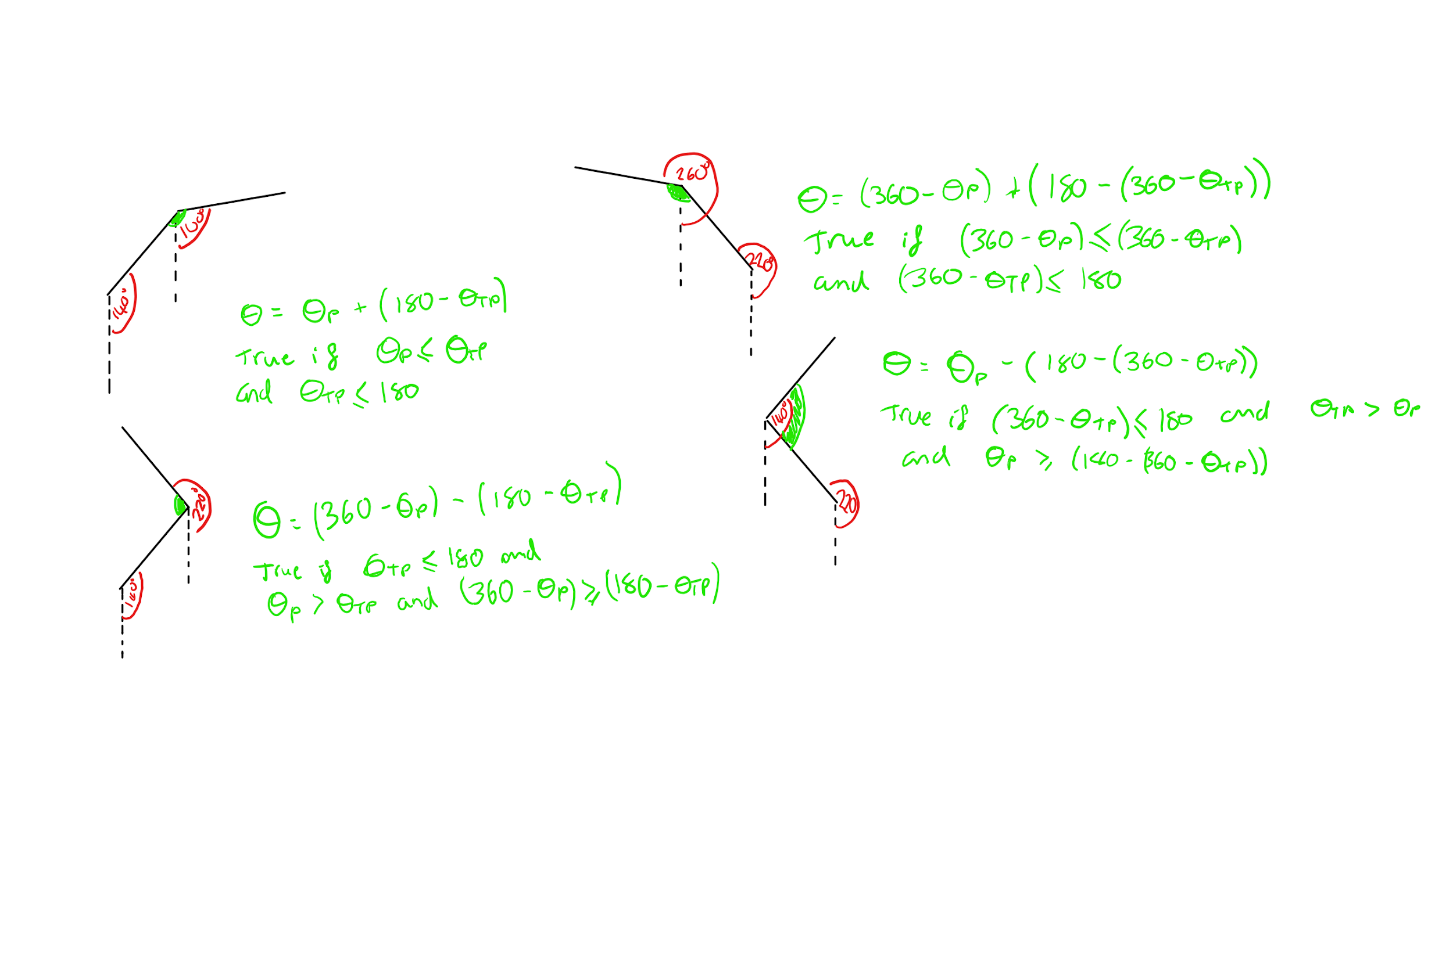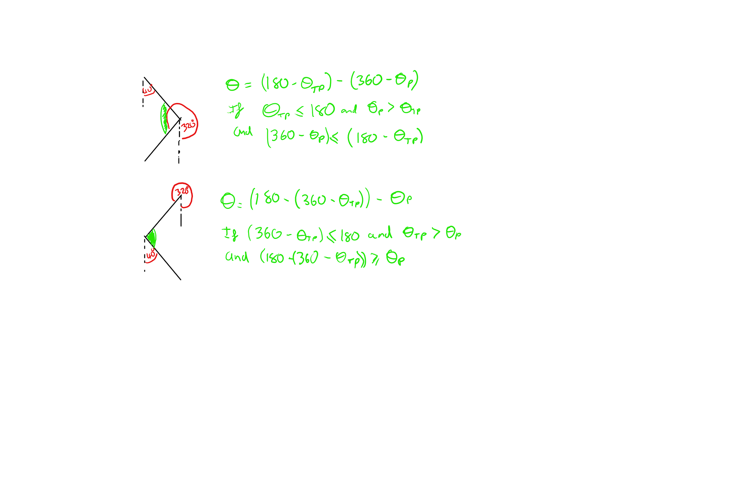

It takes 2 angles one being thetaP and the other thetaTP, these are labelled like that cause usally it is used to calculate the green angle where the green is where player is. Made so hideous with if statements due to edge cases and the way the angle system works.